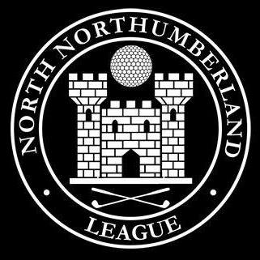NORTH NORTHUMBERLAND LEAGUE OPEN DAY

BURGHAM PARK

**Date: 15th June 2024**

BEST NET

|  |  |  |
| --- | --- | --- |
| NAME: A Straughan | SCORE: 40 | CLUB: Alnmouth Village |

BEST GROSS

|  |  |  |
| --- | --- | --- |
| NAME: David Baker | SCORE: 37 | CLUB: Dunstanburgh Castle |

SWEEP (top 3 paid)

|  |  |  |  |
| --- | --- | --- | --- |
| 1st | NAME: A Straughan | SCORE: 40 | CLUB: Alnmouth Village |
| 2nd | NAME: D Baker | SCORE: 39 | CLUB: Dunstanburgh Castle |
| 3rd | NAME: R Gander | SCORE: 39 | CLUB: Alnmouth |
| 4th | NAME: S Watson | SCORE: 39 | CLUB: Burgham Park |

TEAM RESULTS

|  |  |  |
| --- | --- | --- |
| TEAM | TEAM NET POINTS | TEAM GROSS POINTS |
| Alnmouth Village | 133 | 84 |
| Alnwick Castle | 133 | 81 |
| Burgham Park | 143 | 113 |
| Dunstanburgh | 144 | 116 |
| Linden Hall | - | - |
| Rothbury | 138 | 114 |
| Seahouses | - | - |
| Warkworth | 142 | 88 |

Points of note:

(Hole in one, Weather)